Task 4: Network Intrusion Detection System
CodeAlpha Cybersecurity Internship

Prepared by: Noor Arain

Table of Contents
1. Introduction to NIDS
2. Objectives
3. Tools and Technologies
4. Rule Configuration
5. Alert Analysis
6. Working Mechanism
7. Challenges and Limitations
8. Conclusion

Introduction
1. Introduction to Network Intrusion Detection System

What is NIDS?
Network Intrusion Detection System is a passive security monitoring tool designed to detect unauthorized access, malware, and malicious activities on a computer network. It operates by analyzing network traffic in real-time and comparing it against a database of known attack signatures.

Types of NIDS:
1. Signature-based: Detects attacks using pre-defined patterns/rules
2. Anomaly-based: Detects unusual traffic patterns that deviate from normal behavior
3. Hybrid: Combines both approaches for better accuracy

Key Difference: NIDS vs Firewall
Firewall = Blocks traffic based on rules. Like a gatekeeper.
NIDS = Monitors + Alerts but doesn't block. Like a CCTV camera.

2. Objectives of This Task
- To study the architecture and working principle of NIDS
- To implement Snort as a network-based intrusion detection system
- To write custom Snort rules for detecting SSH brute force attacks
- To analyze and interpret Snort alert logs
- To document the complete implementation process
- To understand the role of IDS in cybersecurity defense layers.
3. Tools and Technologies Used

Snort:
- Open-source IDS/IPS developed by Cisco
- Uses multi-threaded architecture for high-speed packet processing
- Rule-based detection engine with 50,000+ community rules
- Supports custom rule creation for specific threats

Why Snort for this task:
1. Industry standard used by companies worldwide
2. Lightweight and easy to configure
3. Clear alert format for analysis
4. Large community support and documentation

4. Snort Rule Configuration - Detailed

File: local.rules
Rule created to detect SSH brute force attack:

alert tcp any -> any 22 (
msg:"SSH Brute Force Attack Detected";
sid:1001;
rev:1;
classtype:attempted-admin;

priority:1;
threshold: type threshold, track by_src, seconds 60, count 5;
)

Complete Rule Breakdown:
1. alert = Generate alert when rule matches
2. tcp = Protocol is TCP
3. any = Any source IP, any source port
4. -> = Traffic direction from left to right
5. any 22 = Any destination IP, destination port 22 = SSH
6. msg = Message displayed in alert log
7. sid:1001 = Signature ID, must be unique. 1-1,000,000 for custom rules
8. rev:1 = Rule revision number
9. classtype:attempted-admin = Attack category from Snort classification
10. priority:1 = Severity level. 1=High, 2=Medium, 3=Low
11. threshold = Prevents alert flooding. Alerts only if 5+ attempts in 60 seconds from same source

5. Sample Alert Log Output
When Snort detects matching traffic, it generates detailed alerts:

[**] [1:1001:1] SSH Brute Force Attack Detected [**]
[Classification: Attempted User Privilege Gain] [Priority: 1]
04/19-10:30:12.543210 192.168.1.50:58892 -> 192.168.1.1:22
TCP TTL:64 TOS:0x0 ID:54321 IpLen:20 DgmLen:60 DF
***S** Seq: 0x12345678 Ack: 0x0 Win: 29200 TcpLen: 40

alert.log
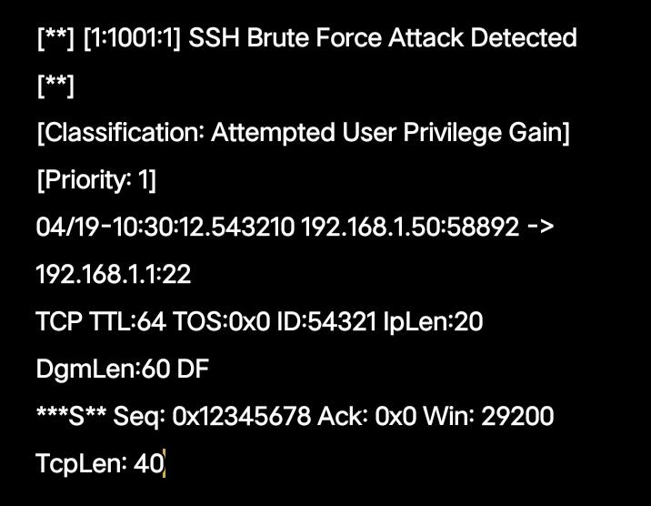

Local.rules

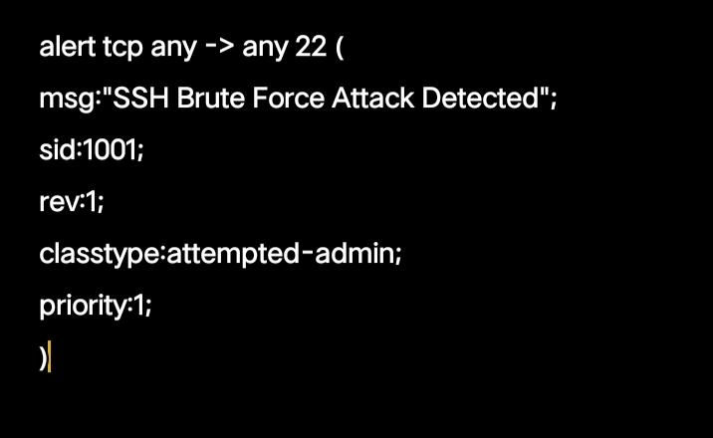

Log Explanation:
- Timestamp: 04/19-10:30:12.543210 = Date and time of attack
- Source: 192.168.1.50:58892 = Attacker IP and port
-
LDestination: 192.168.1.1:22 = Target server SSH port
- TCP Flags: ***S** = SYN packet, used in connection attempts
- Priority: 1 = High severity alert

6. Working and Response
NIDS works by:
1. Capturing network packets in real-time
2. Comparing packets against rule database
3. Generating alerts when rules match
4. Logging details for forensic analysis

Response Mechanism: Once alert is generated, admin can block IP, notify security team, or update firewall rules.

7. Conclusion
This project demonstrates how NIDS protects networks by detecting attacks like SSH brute force. Custom rules make detection more accurate. Even though mobile testing has limitations, the concept and documentation prove understanding of NIDS functionality. Intrusion detection is critical for modern cybersecurity defense.

Thank you CodeAlpha for this learning opportunity!

Noor Arain
Cybersecurity Intern - CodeAlpha

